
Europass  Curriculum Vitae |  | 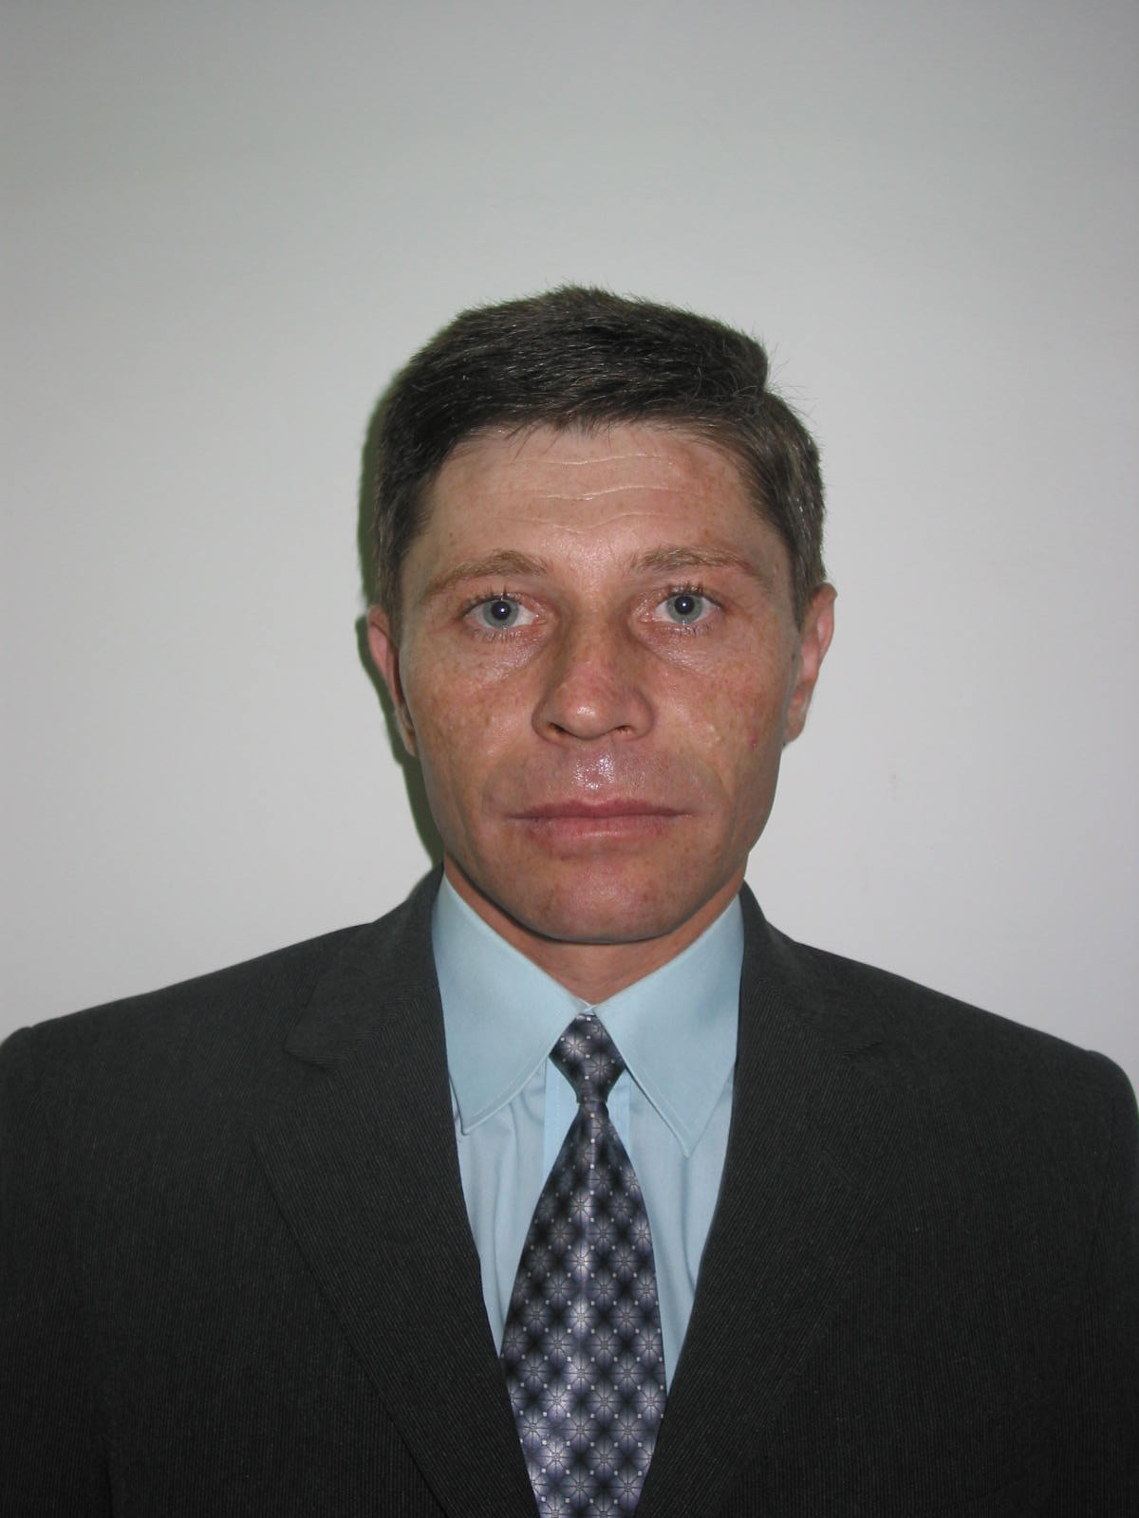
Personal information
First names / Surname |  | TOMA CONSTANTIN
Address |  | 22, Carol I Boulevard, Iaşi RO – 700505, B608, 3th floor, Building B
Telephone |  | 0232/201389
Email |  | toco@uaic.ro
Nationality |  | Romanian
Year of birth |  | 1968
Gender |  | Male
Work experience
Dates |  | 2024-present
Position held |  | Full professor PhD
Main activities and responsibilities |  | Teaching and research
Name and address of employer |  | "Alexandru Ioan Cuza" University of Iași, Economics and Business Administration Faculty, Accounting, Business Information Systems and Statistics Department, 22, Carol I Boulevard, Iaşi RO – 700505
Type of business or sector |  | Higher education and research
Dates |  | 2002-2024
Position held |  | Associate professor PhD
Main activities and responsibilities |  | Teaching and research
Name and address of employer |  | "Alexandru Ioan Cuza" University of Iași, Economics and Business Administration Faculty, Accounting, Business Information Systems and Statistics Department, 22, Carol I Boulevard, Iaşi RO – 700505
Type of business or sector |  | Higher education and research
Dates |  | 1999-2002
Position held |  | Lecturer PhD
Main activities and responsibilities |  | Teaching and research
Name and address of employer |  | "Alexandru Ioan Cuza" University of Iași, Economics and Business Administration Faculty, Accounting Department, 22, Carol I Boulevard, Iaşi RO – 700505
Type of business or sector |  | Higher education and research
Dates |  | 1996-1999
Position held |  | Assistant
Main activities and responsibilities |  | Teaching and research
Name and address of employer |  | "Alexandru Ioan Cuza" University of Iași, Economics and Business Administration Faculty, Accounting Department, 22, Carol I Boulevard, Iaşi RO – 700505
Type of business or sector |  | Higher education and research
Dates |  | 1993-1996
Position held |  | Junior assitant
Main activities and responsibilities |  | Teaching and research
Name and address of employer |  | "Alexandru Ioan Cuza" University of Iași, Economics and Business Administration Faculty, Accounting Department, 22, Carol I Boulevard, Iaşi RO – 700505
Type of business or sector |  | Higher education and research
Education and training
Dates |  | 2023
Title of qualification awarded |  | Habilitation certificate – Accounting field (OME, no. 6359/27.09.2023)
Name and type of organization providing education and training |  | The Ministry of Education and "Alexandru Ioan Cuza" University of Iași, Doctoral School of Economics and Business Administration
The title of the thesis |  | Thrue and fair view – fundamental objective of financial reporting and the relationship with the decision – making process. External growth of companies and the economy
Dates |  | 2021
Title of qualification awarded |  | Training certificate regarding the quality management of study programs in the forms of Distance Education and Low Frequency Education
Name and type of organization providing education and training |  | Romanian Agency for Quality Assurance in Higher Education(ARACIS) – București
Dates |  | 2016-2017
Title of qualification awarded |  | Certificate of completion of the Psychopedagogical training program
Name and type of organization providing education and training |  | Department for the Training of Teaching Staff, Faculty of Psychology and Educational Sciences, "Alexandru Ioan Cuza" University of Iași
Dates |  | 01.10.2009-04.11.2009
Title of qualification awarded |  | Certified trainer
Name and type of organization providing education and training |  | Interactiv RO Consult Bacău
Level in national or international classification |  | COR code 241245
Dates |  | 1994-2001
Title of qualification awarded |  | PhD in Accounting
Principal subjects |  | The annual accounts and true and fair view in accounting
Name and type of organization providing education and training |  | "Alexandru Ioan Cuza" University of Iași
Level in national or international classification |  | Postgraduate – level 8 – ISCED
Dates |  | 1987-1992
Title of qualification awarded |  | Bachelor's degree
Name and type of organization providing education and training |  | "Alexandru Ioan Cuza" University of Iași, Faculty of Economics
Level in national or international classification |  | University education, level 6 – ISCED
Personal skills and competences
Native language |  | Romanian
Other languages  Auto evaluation |  |  | Understanding |  |  |  | Speaking |  |  |  | Writing
 |  |  | Listening |  | Reading |  | Spoken interaction |  | Speech
French |  |  | B1 | Independent User | B2 | Independent User | B1 | Independent User | A2 | Basic User | A2 | Basic User
English |  |  | A1 | Basic User | A1 | Basic User | A1 | Basic User | A1 | Basic User | A1 | Basic User
Computer skills and competences |  | Using general software (Microsoft Office) and accounting software
Social skills and competences |  | Team spirit, responsible, dynamic, communicative
Organisational skills and competences |  | Developed leadership skills and coordination responsibilities held after relations with students or due to positions held  - Vice-Dean of Economics and Business Administration Faculty (2004-2008);  - Director of Department of the Business Administration (2008-2012);  - President of CAR "Alexandru Ioan Cuza University" - IFN from 2003;  - Administrator of the "Economist 2000" Foundation.
Research activity |  | - 29 scientific articles published in full (of which: 4 articles in Web of Science cited journals with impact factor; 5 articles in Web of Science cited journals without impact factor and ISI Proceedings and 20 articles in BDI indexed journals and journals of specialty);  - 61 participations in national and international conferences;  - 26 books, textbooks and course materials published, as author or co-author, in publishing houses recognized at the national level, of which: a book by author has reached the 3rd edition and a book (co-author) of been reissued;  - 49 chapters/studies in specialized books or volumes;  - coordination of 3 volumes published in nationally recognized publishing houses;  - 18 research projects/contracts;  - UEFISCDI 2021 award for research results.
Editorial activities |  | - editorial board member at the BDI-rated publication, The Journal of Accounting and Management, "Danubius" Galați University;  - scientific referent for 6 published books.

Date: Signature:
7.02.2024 Toma Constantin

